**Project Design Phase-II**

**Solution Requirements (Functional & Non-functional)**

|  |  |
| --- | --- |
| Date | 10 October 2022 |
| Team ID | PNT2022TMID17812 |
| Project Name | Gas Leakage Monitoring and Alerting System |
| Maximum Marks | 4 Marks |

**Functional Requirements:**

Following are the functional requirements of the proposed solution.

|  |  |  |
| --- | --- | --- |
| **FR No.** | **Functional Requirement (Epic)** | **Sub Requirement (Story / Sub-Task)** |
| FR-1 | User Registration | Registration through Form  Online Payment for the service |
| FR-2 | User Access | Access the details using web browser  Access the details using mobile application |
| FR-3 | User alert | Gets alert as an SMS message  Gets alert alarm in the working area. |

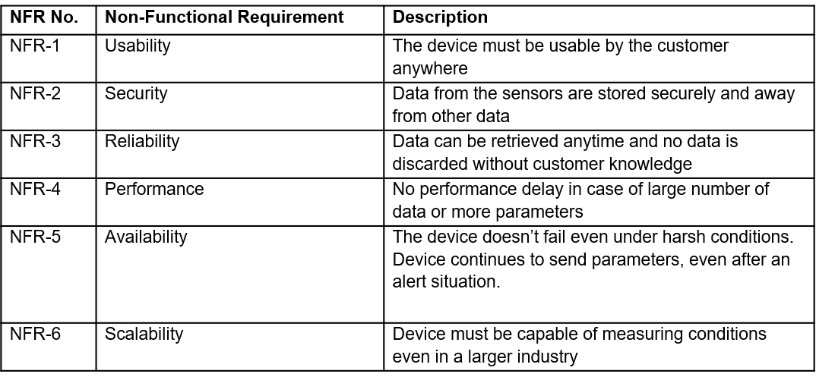

**Non-Functional Requirements:**

Following are the non-functional requirements of the proposed solution.